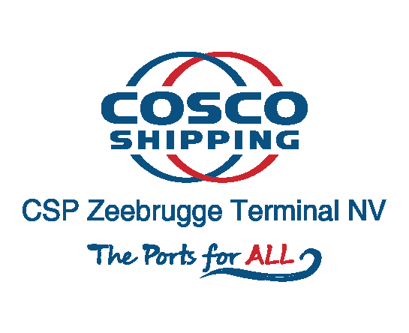

CSP Zeebrugge Terminal Preannouncement

Contact info: : Zeebrugge.tas@cspterminals.com
Tel: 0032 50 50 26 26 0032 50 50 26 01

Table of Contents
- Sign in .......................................................................................................................... 3
- User Management ……………………………………………………..………………………………………….. 4
2.1 Different user roles ……….………………………………………………………………………………………………...………… 4
2.2 Create new user ……………………………………………………………………………………………………………...………… 4
2.3 Edit user details ……………………………………………………………………………………………………………...….……… 5
2.4 Revoke and restore access …………………………………………………………………………………………...…………… 6
2.5 Remove a user account ………………………………………………………………………………………………..…………… 6
3 Truck fleet management .............................................................................................. 7
3.1 Create new truck.............................................................................................................................. 7
3.2 Edit truck ......................................................................................................................................... 7
3.3 Remove truck .................................................................................................................................. 8
3.4 Filter truck list …………………………………………………………………………………………………………..…….………… 8
4 Appointment menu ..................................................................................................... 9
4.1 Create new appointments ….......................................................................................................... 10
Step 1: Reserve timeslot for new appointment..........................................................................................10 Step 2: Enter the container unit details ..................................................................................................... 12
Possible transactions ............................................................................................................................13
- Drop off unit .................................................................................................................... 13
  - Drop off empty unit ...................................................................................................13
  - Drop off full unit ....................................................................................................... 14
- Collect unit ...................................................................................................................... 16
  - Pick up empty unit ................................................................................................... 16
  - Pick up full unit ........................................................................................................ 17
Step 3: Enter the truck details ................................................................................................................... 19
Step 4: Select a driver ...……….................................................................................................................... 20
Step 5: Submit the appointment................................................................................................................ 20
4.2 Activate an appointment .............................................................................................................. 22
4.3 Cancel an appointment ................................................................................................................. 22
4.4 Delete an appointment.................................................................................................................. 23
4.5 Reschedule an appointment ......................................................................................................... 23
4.6 Edit Appointment Details…………………………………………………………………………………………………………..25
4.7 View appointment details / Manage appointments ..................................................................... 25
5 Find unit menu........................................................................................................... 25

1 SIGN IN

- https://tas.cspterminals.be (The link only works properly with Google chrome)
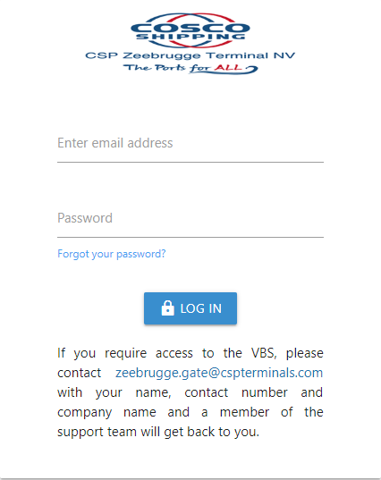
- A smartphone application will be made available in a later stage. Instructions and information will be communicated as soon as this is operational.

1.1 VBS STEPS

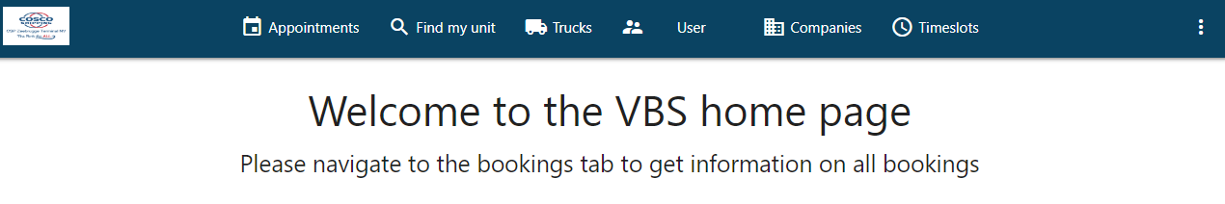
Truck appointment steps:
- Log into the VBS application to book truck appointments.
- Reserve a timeslot to drop/collect a shipping container.
- Provide the appointments details.
- Confirm the appointment.
- Assign truck and driver.
- Inform the truck driver of the appointment and ask them to activate the appointment at the proper time or activate it yourself.

2 USER MANAGEMENT

2.1 DIFFERENT USER ROLES

- Haulier Admin
  - This person is the administrator of his own company
  - Can make changes to the profile of the company
  - Can view and add trucks of own company
  - All actions of preannouncements within own company (Create, Read, Update, Delete, Activate & Deactivate)
- Haulier User
  - This person can manage all drivers for his own company
  - View his own company details, so can’t make any changes to the profile of the company
  - Can view, add and edit trucks of his own company
  - All actions of preannouncements within own company (Create, Read, Update, Delete, Activate & Deactivate)
- Driver
  - Haulier Driver
    - Sees appointments that are assigned to him
    - Create, activate & deactivate bookings
    - Can only see the trucks of his own company, cannot edit these

2.2 CREATE NEW USER

Before you can provide VBS access to users, you must create the users and add them to the appropriate user group. This is done in the Users menu. To add a user:
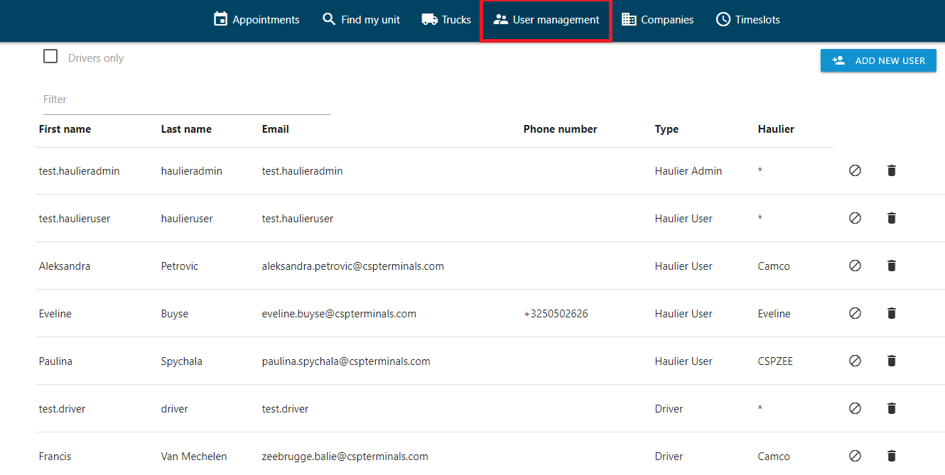

- In the Users menu, click ADD NEW USER.
- In the user creation screen, enter the details for the new user account, such as name, phone, email, language, etc
  - Every driver needs an own e-mail address in order to be able to activate appointment for and link the appointment to the proper driver.
- Select the user group to which this new user must be added
  - When Creating a Driver, CORRECT Alfapass Number is Mandatory, otherwise the driver won’t be able to enter the terminal.
  - When creating a Haulier Admin or Haulier User alfapass is required, but can be any random number (not all admins or planners have an alfapass).
  - In case the Haulier Admin or Haulier User is the same as the Driver then Alfapass is mandatory.
- Select the company associated with this new user
- Click CONFIRM

The user account will be created, and the user will receive an email with further instructions, amongst which the request to set his password.

2.3 EDIT USER DETAILS

Administrators can modify user details, such as name, phone, email, language, or change the role of a specific user in the Users menu. To modify user details:
- In the Users menu, select the user from the list.
- In the user details screen, click EDIT USER on top of the screen.
- In the edit screen, update the details and finally click UPDATE USER. The user will be informed by email on the changes.

2.4 REVOKE AND RESTORE ACCESS

Administrators can temporarily revoke VBS access for a specific user.
- In the Users menu, find the user in the list.
- Click the revoke access icon.
- Confirm that you want to block this user from VBS. Revoked users will appear in red.
Similarly, you can restore access by clicking the restore access icon.

2.5 REMOVE A USER ACCOUNT

Administrators can permanently remove a user account.
- In the Users menu, find the user in the list.
- Click the delete icon.
Confirm that you want to permanently remove this user account.

3. Beheer Wagenpark

3.1 Aanmaken van een truck

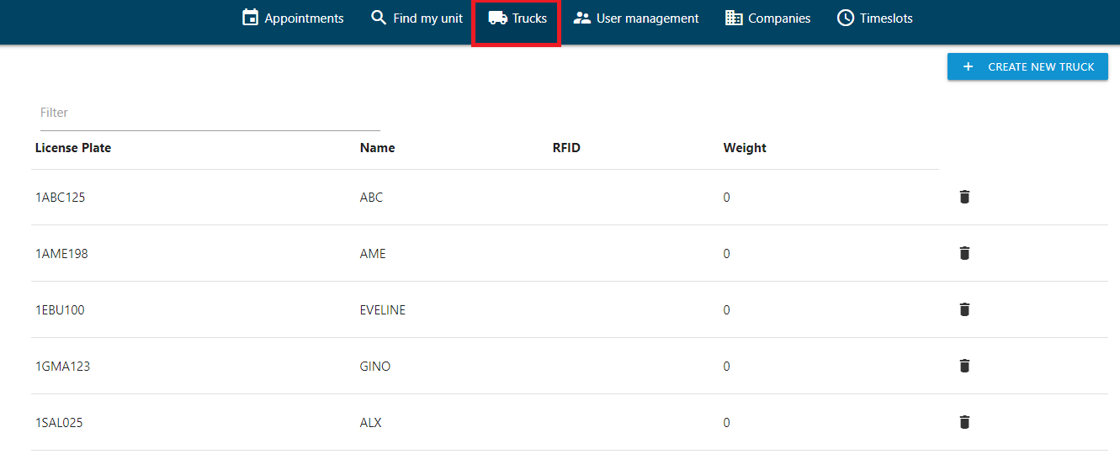
To add a truck to the truck fleet list, go to the Trucks menu and click CREATE NEW TRUCK.
- Enter the License plate.
- Enter the name.
- The RFID tag not mandatory
- Enter the weight. (not applicable)
- Click CREATE TRUCK to complete the process, the newly created truck will be added

3.2 EDIT TRUCK
To update the details of a truck, select the truck from the truck fleet list.
In the edit form, update the details and click UPDATE TRUCK to save the changes.

3.3 REMOVE TRUCK
To permanently delete a truck from the truck fleet list, click the corresponding Delete icon. The truck will be removed from the list.

3.4 FILTER TRUCK LIST

To quickly find a truck in the list of trucks, use the Filter option on the top left. The list will be filtered based on the string you enter in the Filter text box.

4 APPOINTMENT MENU

The appointment menu allows you to create, activate and follow up on truck appointments to drop and collect shipping containers.
The screen gives an overview of previously created appointments:
- Appointments that require attention: these are truck appointments that are not yet complete nor validated against the TOS (status: pending)
- Confirmed appointments: these are truck appointments that are complete and validated against the TOS, but not yet activated (status: created) . Multiple appointments are possible per driver.
- Active appointments: these are truck appointments that are already activated (status: active) . Only one active appointment is possible per driver.
- Closed appointments: these are truck appointments that have been fully handled (status: closed). Closed appointments are removed after 12 hours. With closed appointments we mean those that are consumed (finished) or expired (time slot).
In the list, each appointment is shown with info such as the appointment time, license plate, number of units to drop/collect and appointment reference.
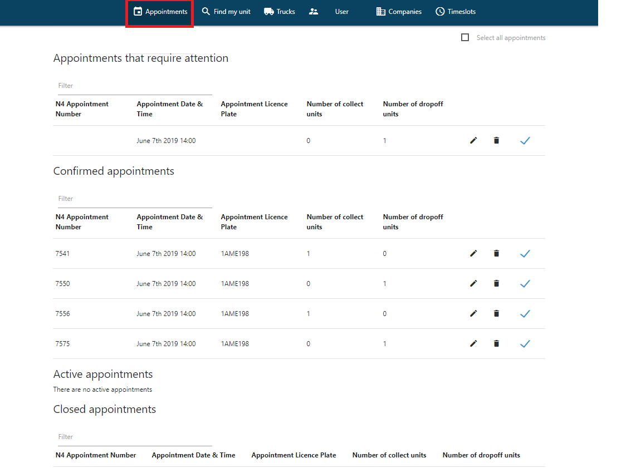
Actions:
- To delete a truck appointment, find it in the list and click the corresponding delete icon.
- To activate a truck appointment, select it from the list and choose ACTIVATE APPOINTMENT (see page 16)
- To assign a truck appointment to a driver, select it from the list, select the driver and choose ASSIGN.
- To reschedule a truck appointment, select it from the list and choose RESCHEDULE APPOINTMENT (see page 17). Reschedule can only be done as long as time slot has not expired.
- To remove the link between a truck appointment and the timeslot, select it from the list and choose CANCEL APPOINTMENT (see page 17)
- To create a new truck appointment, select CREATE NEW APPOINTMENT. See below.

4.1 CREATE NEW APPOINTMENTS

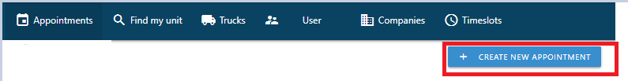
When you create a new appointment, you first reserve a timeslot and afterwards follow the wizard to provide the appointment details.

Step 1: Reserve timeslot for new appointment

- In the Appointment menu, choose CREATE NEW APPOINTMENT.
The appointment calendar is shown. Note that this calendar can be viewed by month / week / day.

- Select an available timeslot from the calendar for the new appointment. The Timeslot details screen appears.
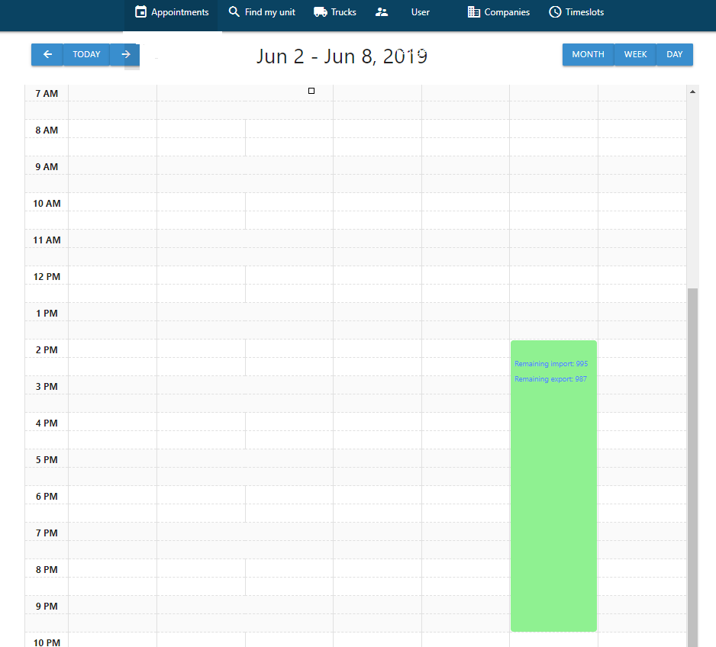 | Click on the timeslot

- Click ASSIGN TIMESLOT to reserve this timeslot.

The appointment details screen appears, listing the selected timeslot.
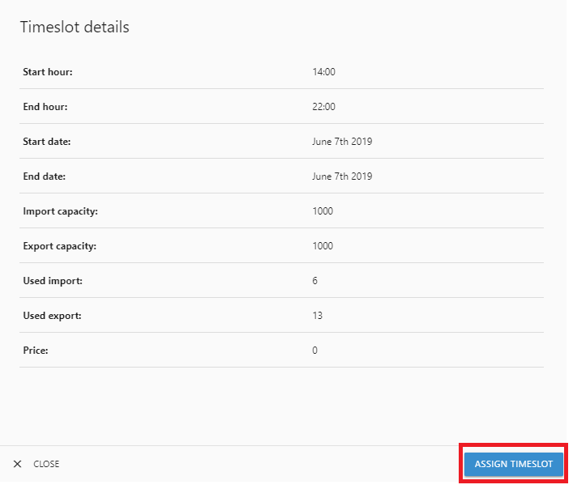
When you click ASSIGN TIMESLOT, you will get following appointment details overview.
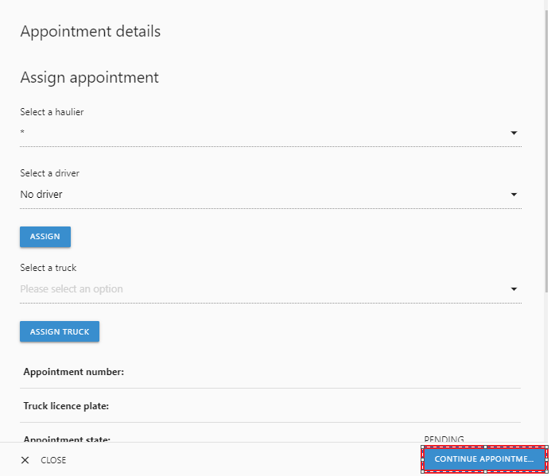 | You don’t have to fill in any information.  Click ‘CONTINUE APPOINTMENT’

- Appointments can be used one day in advance until the end of the time slot for which the appointment has been made. Note that this is temporary and will be changed in the future.

Step 2: Enter the container unit details

Click ADD UNIT to start with the first container.

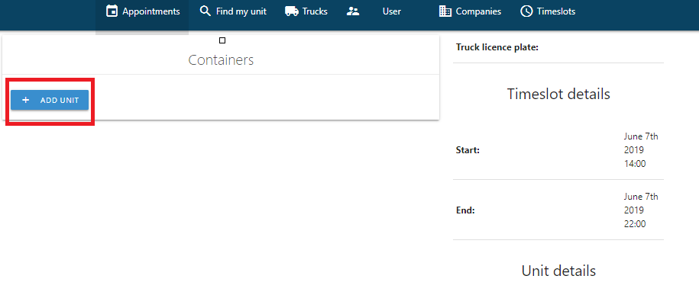
In the next screens, you need to provide details on the containers that will be dropped and/or collected.

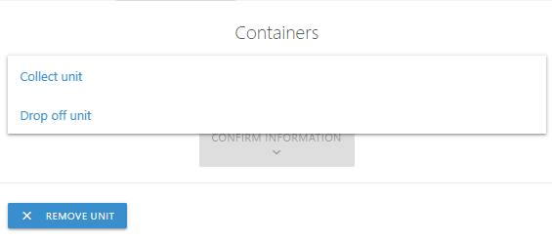
Select ‘Collect unit’: when you want to pick up a container.
Select ‘Drop Off unit’: when you want to drop off a container.

Possible transactions

- Drop off unit

  - These are the requirements for dropping off an empty unit
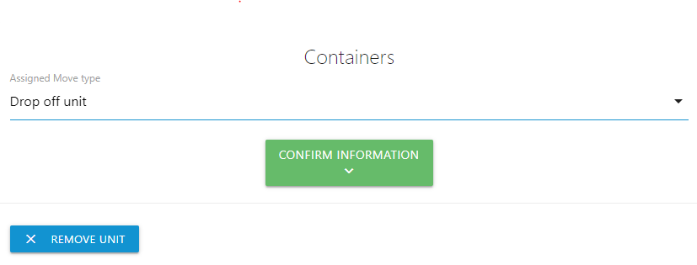
Click CONFIRM INFORMATION

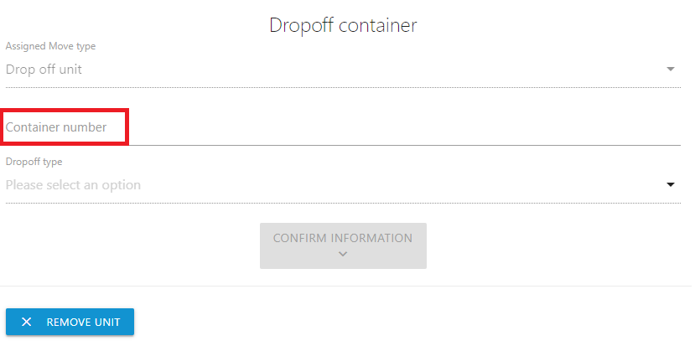

Fill in the container number

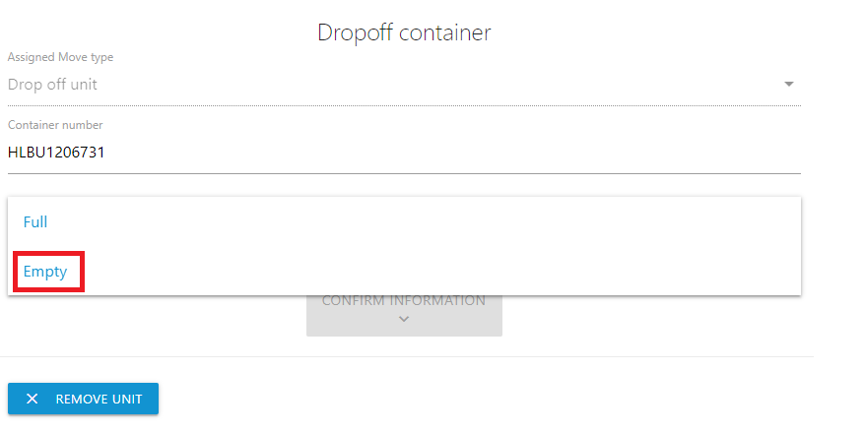

Select EMPTY and click CONFIRM INFORMATION

Fill in ERO and click CONFIRM INFORMATION
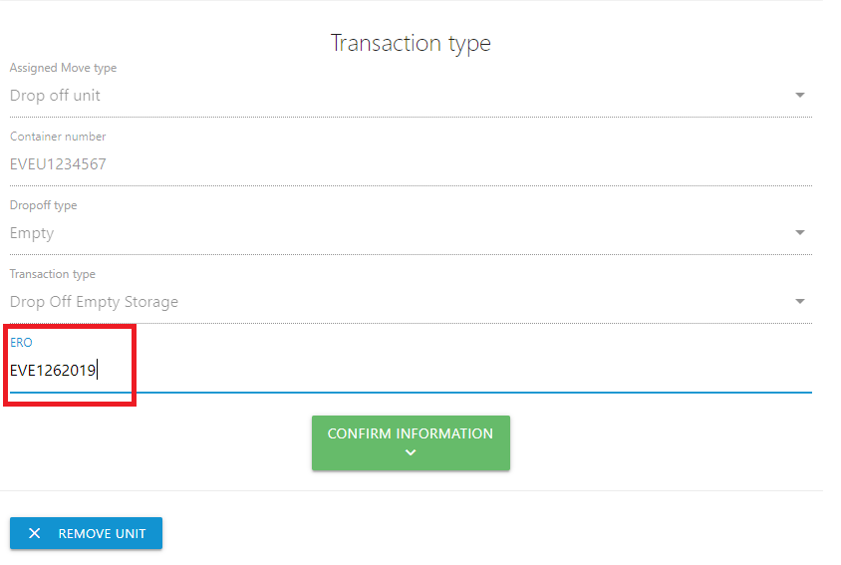

  - These are the requirements for dropping off a full unit
Fill in the container number

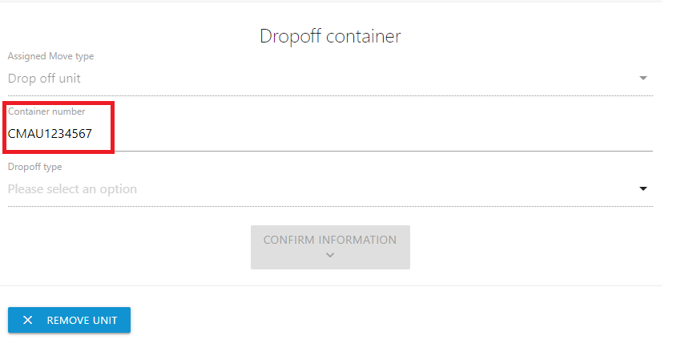

Fill in the container number

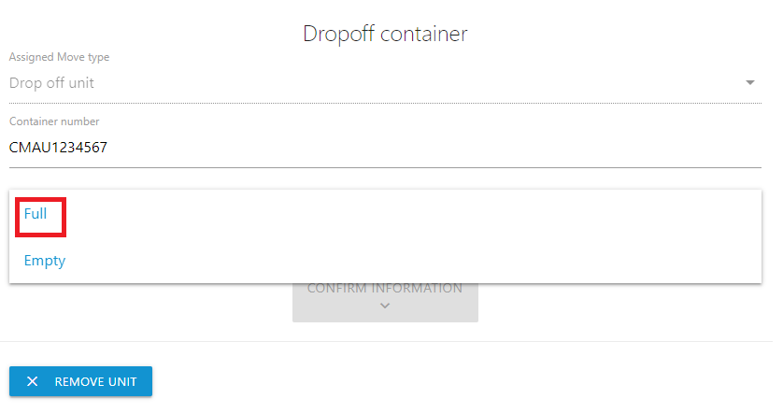
Select FULL and click CONFIRM INFORMATION

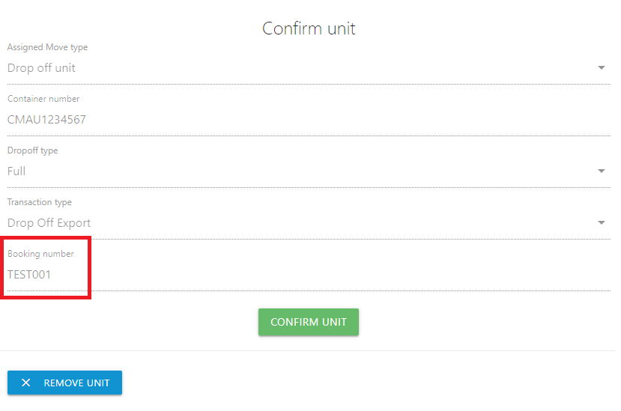

Transaction Type will be filled in automatically.

Fill in BOOKING NUMBER and click CONFIRM INFORMATION

- Collect unit

  - These are the requirements to collect an empty unit
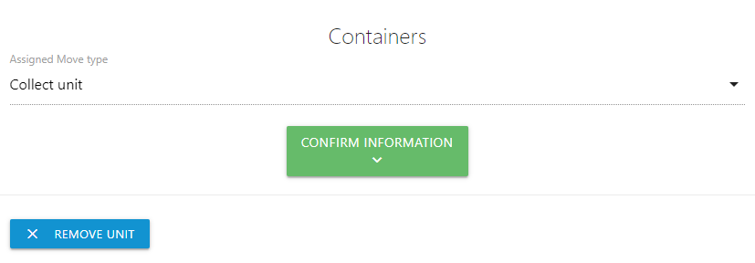
Select COLLECT UNIT and click CONFIRM INFORMATION

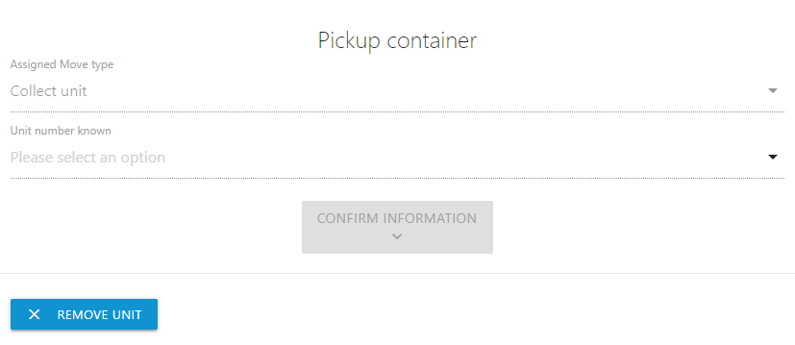 | If container number is known, select YES and fill in the number.  If container number is not known, select NO

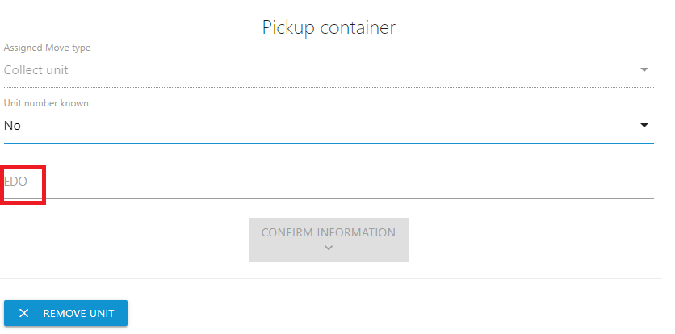

Fill in EDO, this is your booking reference.

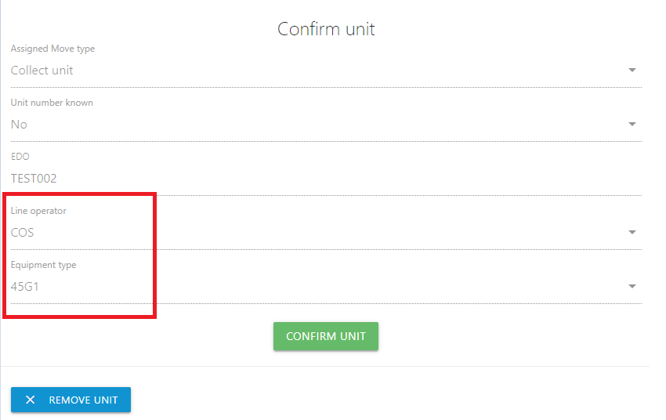

  - These are the requirements to collect a full unit

Select COLLECT UNIT and click CONFIRM INFORMATION
Click YES and fill in the container number

Fill in container number and click CONFIRM INFORMATION

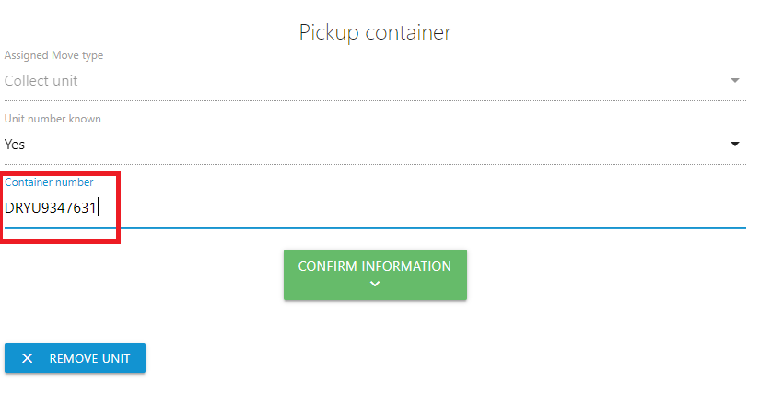
Fill in the PIN number if applicable, click CONFIRM UNIT

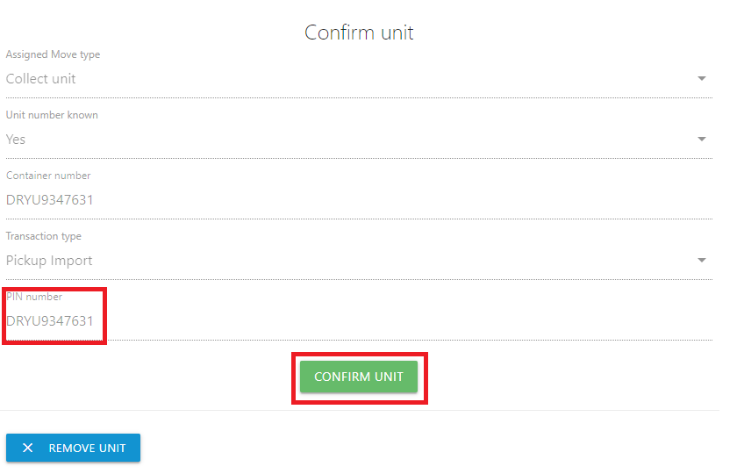

When you want to drop off and pick up at the same time you click ADD UNIT in the following screen.

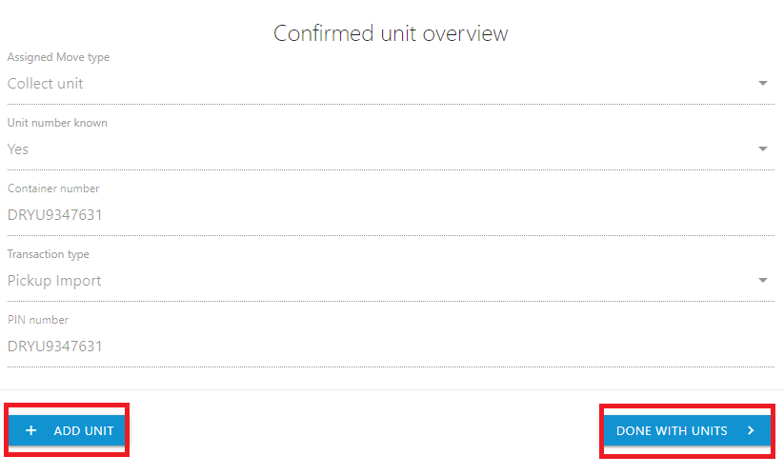 | Click ADD UNIT if you want to drop off and pick up at the same time  Click DONE WITH UNITS if you want to finish your appointment

After you click DONE WITH UNITS you can enter the truck details.

Step 3: Enter the truck details

Select a Truck from the drop-down menu and click DONE WITH TRUCK

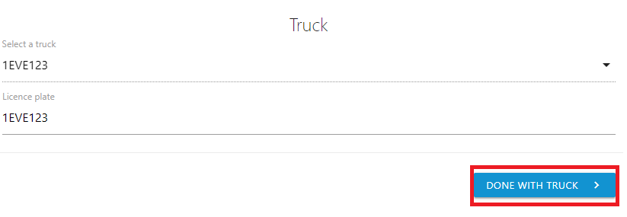
- Step 4: Select a driver

Select a driver and click DONE WITH DRIVER

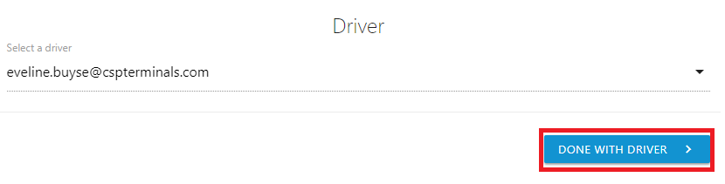

- Step 5: Submit the appointment

After entering all container unit details, the Appointment overview screen sums up all appointment details.
Click SUBMIT to save the appointment.

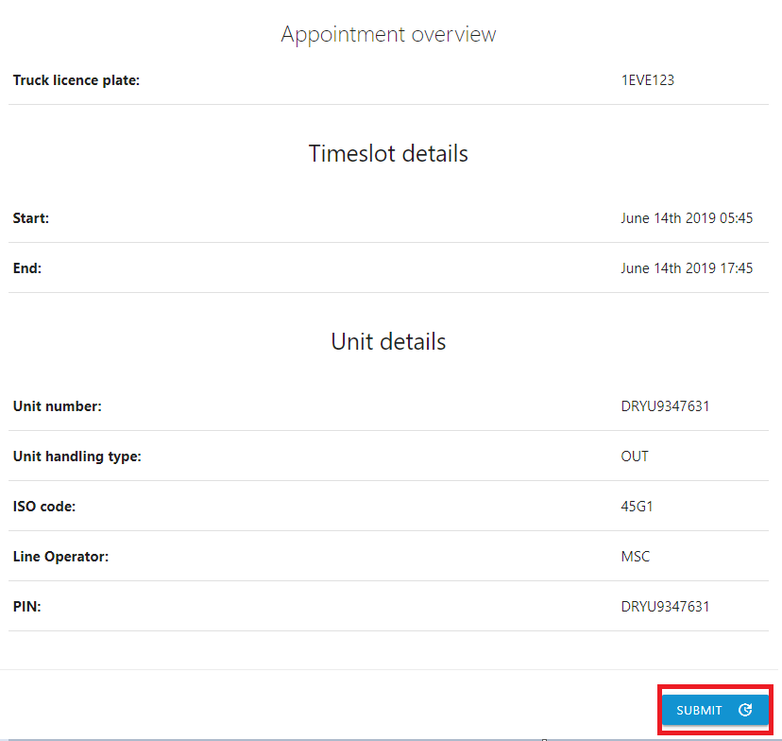

Following screen will appear

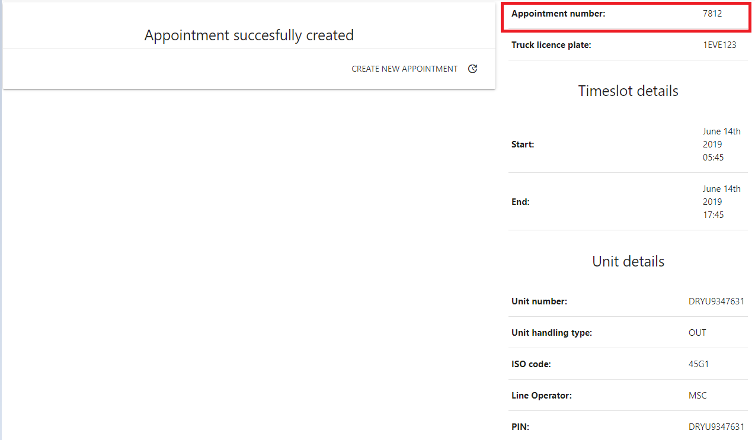

In the APPOINTMENT menu, the newly created appointment will be added to the list of confirmed bookings. It needs to be activated (by the driver) (see page 16) before the driver arrives at the terminal gates.
Once the appointment is successfully created, you won’t be able to edit this appointment. You will have to cancel it and make a new appointment.

4.2 ACTIVATE AN APPOINTMENT

It's important that the truck appointment is activated before the truck driver arrives at the terminal gates. Activating an appointment can be done by the driver or trucking company.
Note that this is only possible for appointments that include all necessary information and are thus shown in the APPOINTMENT menu in the list of Confirmed Appointments. To activate an appointment:
- In the APPOINTMENT menu, open the appointment by selecting it from the list of confirmed appointments.
- Click ACTIVATE APPOINTMENT.
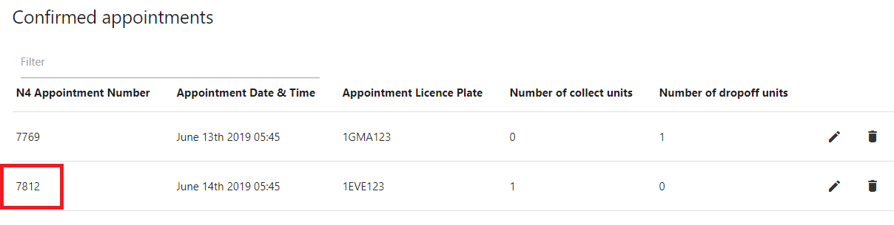
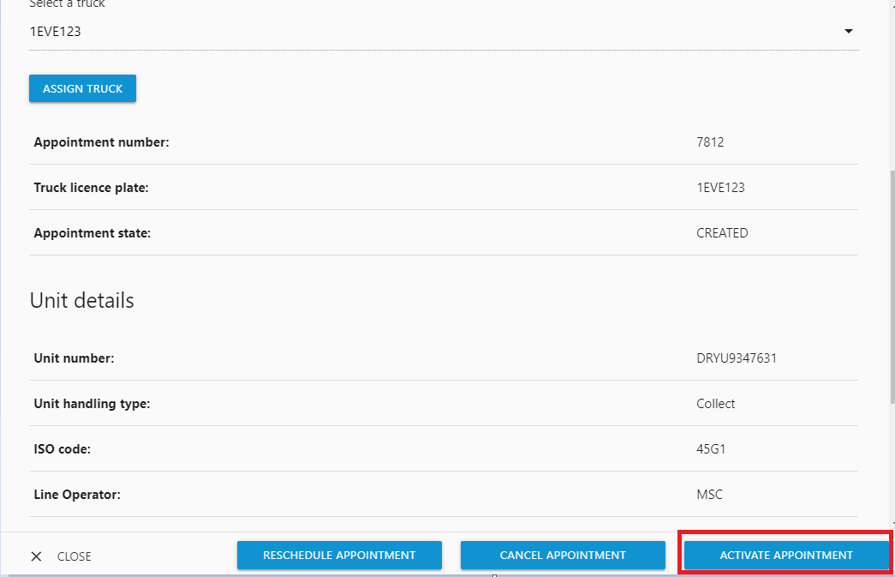

4.3 CANCEL AN APPOINTMENT

To remove the link between a truck appointment and the assigned timeslot:
select it from the list and choose.
- In the Appointment menu, find the appointment that you want to cancel.
- In the edit screen, select CANCEL APPOINTMENT
- Optionally assign another timeslot.
- 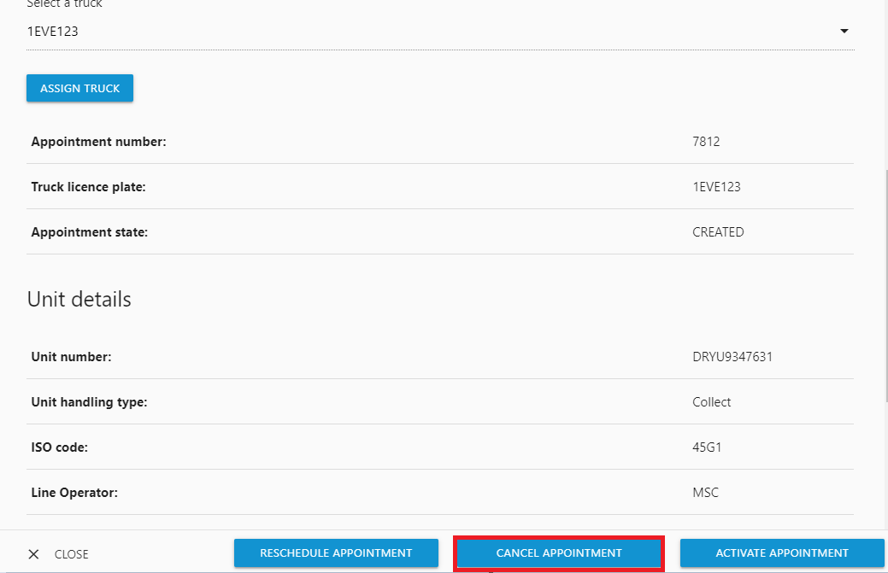

4.4. DELETE AN APPOINTMENT

To permanently remove a previously created truck appointment:
- In the Appointment menu, find the appointment that you want to delete.
- Click the corresponding delete icon.
- Confirm that you want to permanently delete this appointment.
Appointments nearing their execution date can no longer be deleted or deactivated.

4.5 RESCHEDULE AN APPOINTMENT

In case a truck appointment must be rescheduled for a different time, you can simply assign another timeslot to the appointment.
- In the Appointment menu, open the appointment by selecting it from the list of confirmed appointments.
- Click RESCHEDULE APPOINTMENT.
- Select another timeslot.
- Click ASSIGN TIMESLOT.
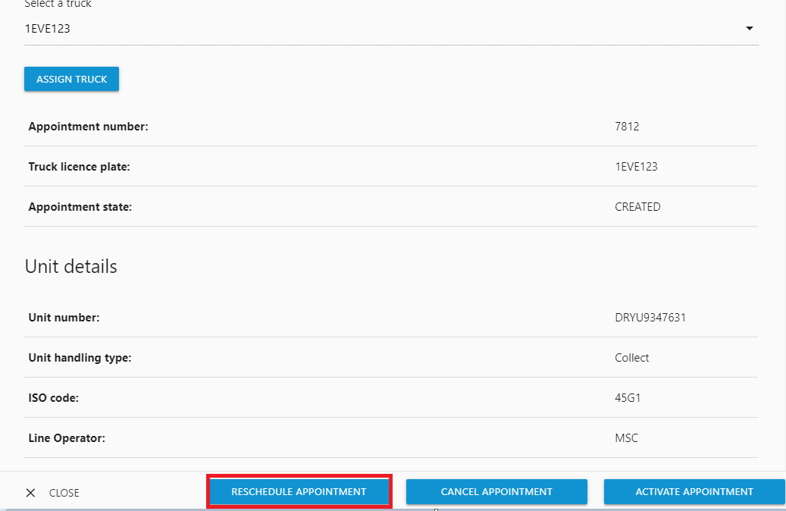
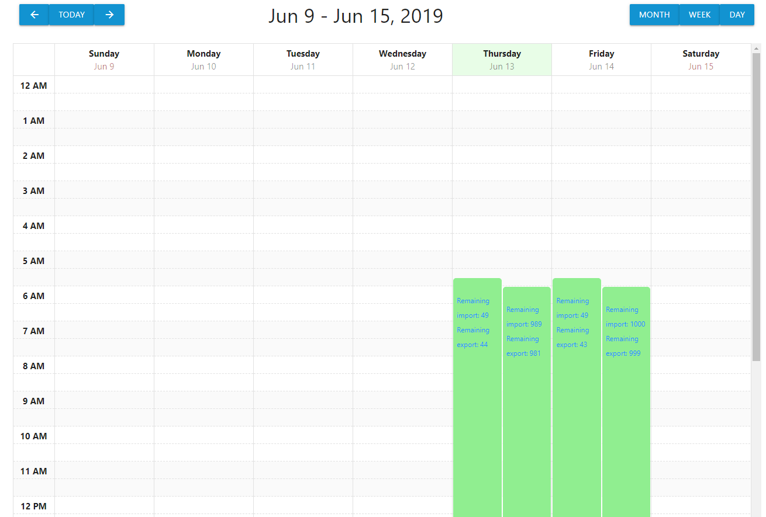

4.6 EDIT APPOINTMENT DETAILS

It is possible to edit an appointment and assign a different driver to an appointment BEFORE the appointment activation. It is possible to assign a new driver or assign another truck.
Go to Confirmed appointments and click the appointment that needs editing.

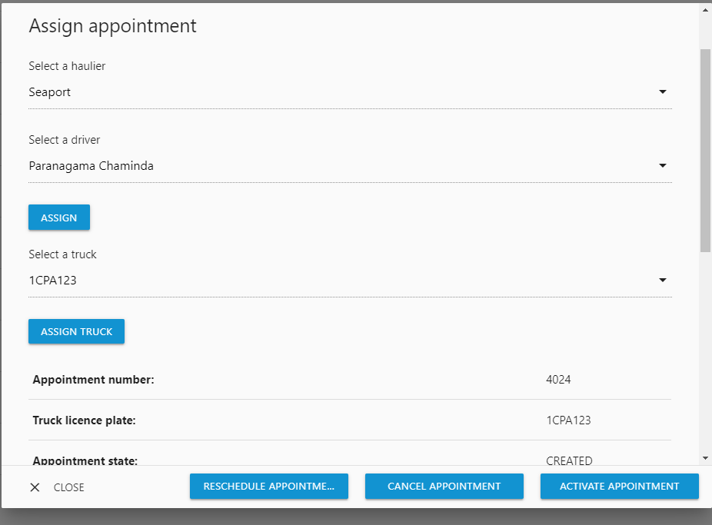

4.7 VIEW APPOINTMENT DETAILS / MANAGE APPOINTMENTS

The Appointment menu allows you to view details of previously made truck appointments.
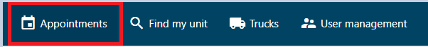

5 FIND MY UNIT

The Find Unit menu allows trucking companies to quickly find a specific container unit and view the associated appointment details.
Click FIND MY UNIT, enter the container unit number and select SEARCH

